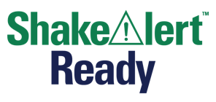
Name: Answer Key - Please note that this key contains possible student responses, and responses will vary. Underlined words indicate words used from the word banks.

Earthquake Early Warning - Student Sheet

Directions: Complete the sentences below. In the Word Bank you will find keywords that you can use in your sentences.

Word Bank:
shake | pieces of Earth | alert | drop
energy | warning | surface | waves
stuck together | cover | hold on | move

Earthquake Basics
An earthquake is _when the ground shakes and causes things and people to move.

An earthquake happens because _the surface of Earth is broken into pieces that move slowly. The pieces of Earth get stuck together, and then suddenly move. This releases energy that travels as waves which cause things to move.

Key Things to Remember to Stay Safe
The key things I need to remember to stay safe if there’s an alert or if I feel shaking are __to Drop, Cover, and Hold On right away.

The most important thing I learned that I will share with my family is __ that we could get an alert that there will be an earthquake. If we do, we need to Drop (or Lock), Cover, and Hold On right away.

Earthquakes are Waves of Energy

Directions: Complete the sentences below. In the Word Bank you will find keywords that you can use in your sentences.

Word Bank:
faster | more damaging | move | slower
up and down | back and forth | less damaging | waves

P-waves are _ seismic waves that are less damaging and move faster.  They cause the material the waves travel through to move _back and forth along the direction the waves are traveling. | Draw a model of a p-wave  or any of these:  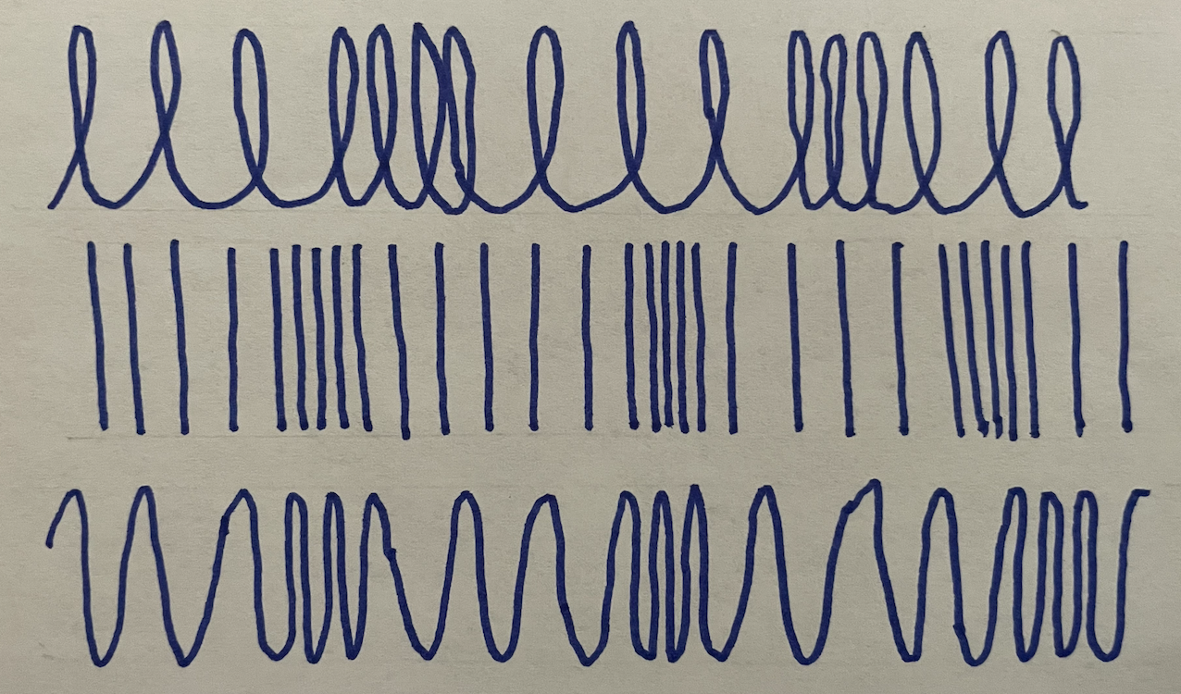

S-waves are __seismic waves that are more damaging and move slower.  They cause the material the waves travel through to move _up and down (perpendicular) to the direction the waves are traveling. | Draw a model of an s-wave  or this:  