School Plan
Your school has taken the critical step to protect your community by installing the ShakeAlert® Earthquake Early Warning System (EEW). Your school is now Powered by ShakeAlert! It could give your staff and students seconds of warning so you can Drop, Cover, and Hold On before damaging shaking from an earthquake reaches you. It is vital to the EEW’s effectiveness to provide intentional, inclusive, and ongoing education to all members of your school community. The goal is that all community members Drop, Cover, and Hold On when they experience an EEW alert or feel ground shaking immediately and without hesitation, which requires practice! To help your school in meeting these educational efforts, the U.S. Geological Survey (USGS) has the following suggested resources.

Intended Time of Year | Resource Link | Purpose & Duration
PowerPoint Note | 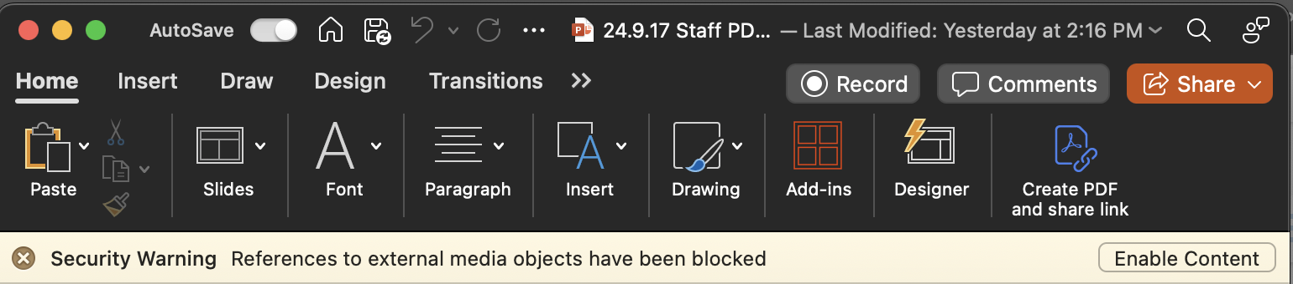  Click “Enable Content” when you open PowerPoint files. This will ensure all animations, video and audio work correctly.
Staff Back to School  (August / September | Staff Back to School Presentation (slides) | (3 minutes) This presentation is designed to be a brief introduction or reminder of the EEW, how it works, and how to respond. Speaker notes are provided.
Staff Professional Development  (1-3 weeks before earthquake drill lessons taught) | Lesson Professional Development (slides) | (30 minutes) This presentation is designed to prepare K-12 teachers to teach ShakeAlert-powered earthquake drill lessons.
ShakeAlert-powered Earthquake Drill (e.g. Great ShakeOut in October) | Family Engagement Letter (English doc & Spanish doc) | Teachers will send this home after conducting their ShakeAlert-powered earthquake drill.
 | K-2 Lesson (slides)  - 1st grade student sheet  - 2nd grade student sheet | (Two 30-minute lessons) Lesson to teach EEW, and practice Drop, Cover, Hold On. Student sheet for K, 1st, and 2nd provided.  OPTIONAL: Print the story, Rocket’s Earthquake Safety Adventure. OPTIONAL: Print or buy Rocket’s Earthquake Safety Activity Book.  OPTIONAL: Encourage schools to sign up for RocketLive!, a 20 minute interactive live earthquake lesson that integrates EEW. (Website LINK, Form LINK)
ShakeAlert-powered Earthquake Drill (e.g. Great ShakeOut in October) | 3-5 Lesson  - 3rd grade student sheet  - 3rd grade ANSWER KEY  - 4th-5th grade student sheet  - 4th-5th grade ANSWER KEY | (60 minutes) Lesson to teach EEW, and practice Drop, Cover, and Hold On. Student sheet for 3rd, and 4th-5th provided.  OPTIONAL: Provide schools with one Giant SlinkyⓇ, 8 small metal Slinkies, or 8 - 2-meter lengths of rope, and a roll of masking tape per classroom.
 | 6-8 Lesson | (30 minutes) Lesson to teach EEW, and practice Drop, Cover, and Hold On.  OPTIONAL: Provide students with an OreoⓇ and fun-size Milky WayⓇ for plate tectonics model.
 | 9-12 Lesson | (15 minutes) Lesson to teach EEW, and practice Drop, Cover, and Hold On.
At a Meeting of Adult Caregivers | Parent / Community Presentation (slides) | (6 minutes) This presentation is designed to be shared at a PTA, PTO, or other parent organization meeting. Speaker notes are provided.

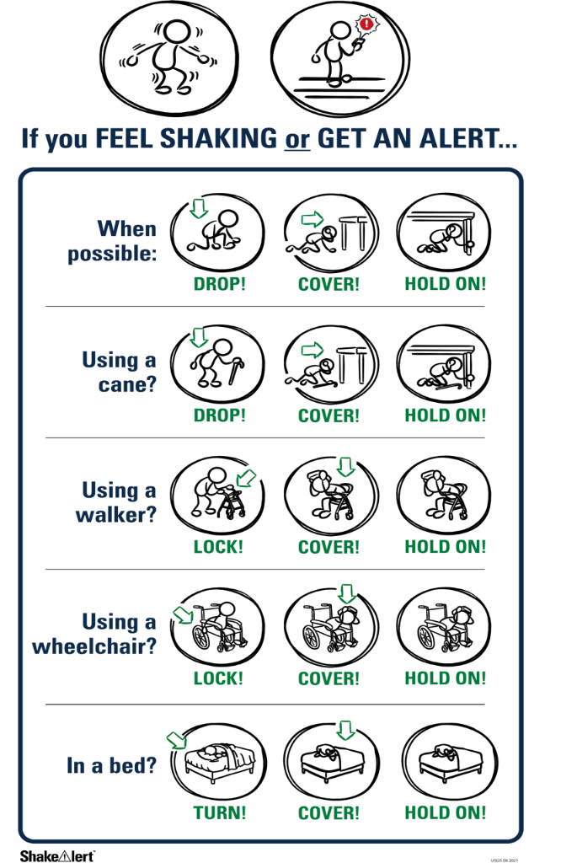 | ShakeAlert Ready! is for the entire school community. Partnership coordinators Katrina Arras (karras@pps.net) and Roger Groom (rgroom@pps.net) provide cost-free assistance in planning or implementing your ShakeAlert Ready! plan. Services they offer include presenting at parent group meetings, professional development gatherings, staff meetings, or working with staff to prepare or model activities. Feel free to share ideas about the EEW resources that would be helpful in your school community!  Now that your school is “Powered by ShakeAlert,” let’s work together to provide awareness, learning, and increased resilience for all members of your school community.  Explore additional ShakeAlert materials shakealert.org.

